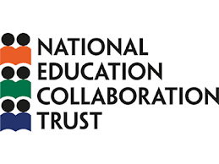
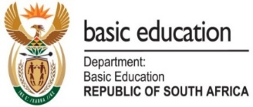

25 AUGUST 2020

BASIC EDUCATION MINISTER ANGIE MOTSHEKGA LAUNCHES WOZA MATRICS: FREE TO AIR TELEVISION PROGRAMME TO SUPPORT 2020 MATRIC LEARNERS

The Minister of Basic Education Mrs Angie Motshekga has today launched Woza Matrics, a free-to-air television initiative that is aimed at supporting the matric learners of 2020 following the disruptions caused by COVID-19.
The Department of Basic Education developed Woza Matrics together with its partners following the many days of lost learning during school closures. While all learners have lost school time, this is most acutely felt by Grade 12s where marks are important for career and university choices and where the content to be covered is fixed and externally examined.
The Council of Education Ministers welcomed the initiative saying that it would go a long way in assisting all learners in matric to prepare for the final examinations which start in November. The CEM urged all learners and parents to make use of the platforms as it would be beneficial to those preparing for the final grade 12 exams under the difficult circumstances resulting from COVID-19.
Woza Matrics is led by the DBE assisted by the National Education Collaboration Trust and developed in collaboration with the South African Broadcasting Corporation (SABC), Multichoice and eMedia Investments as well as with a number of educational content providers (in particular Digicampus, Mindset and Monyetla Trust), the Programme for Improved Learning Outcomes (PILO), and other educationalists.
The 12-week Woza Matrics campaign will start on 1 September 2020 and will support Grade 12 learners in the build-up to their final matric exams by providing quality educational content in the following subjects:
- Maths
- Life Sciences
- Geography
- Physical Science
- Accounting
- Economics
- Math Literacy.
- English First Additional Language
- History
- Business Studies

Woza Matrics will be broadcast on SABC 3, on all DSTV packages and on Openview (Channel 122) from 8:00-10:00 and 13:00-15:00 every day, 7 days a week. It will also be available for free on the DSTV Now Catch up app. A wide-reaching communications campaign will ensure learners, parents and teachers across the country know exactly where to find the subject and content they need each week. A link to support materials will also be made available on 1 September 2020.
Minister Motshekga noted said: “This initiative has come at the right time when we are working to get schooling back on track. Matric is always stressful, but 2020 has been filled with unusual stresses. I want to congratulate all our grade 12 learners and their families for the perseverance and determination. It is abundantly clear that additional support is required for learners and we will continue to provide this. There are a few months left before the end of the year and Woza Matrics will give learners the support they need to prepare for the final exams.”
The Minister has conveyed a message of gratitude to all the partners and sponsors for the role they have played in the development of the programme and availing their platforms for education purposes and the focus on Grade 12 learners in particular.
“I am most grateful to SABC, Multichoice and eMedia Investments who have so generously made their broadcast networks and expertise available to Woza Matrics; and to the content providers (including DigiCampus, Mindset and Monyetla Trust) who have shared all their excellent content with Woza Matrics; to the National Education Collaboration Trust; to PILO and Satrix which has been a major sponsor of PILO’s work on content curation; to the many educators who have been involved in making this happen; as well as to Bidvest and the numerous other sponsors who have helped fund the work which has gone into making Woza Matrics possible,” said Minister Motshekga
The Minister recognised that COVID-19 had brought unusual trauma and stress to teachers, learners, and parents. Woza Matrics has demonstrated the benefit of broad based collaboration between the public and private sector in addressing critical needs. The Minister said she looked forward to further collaborations of this nature.
“As the SABC, we are pleased to be one of the key role players in saving the 2020 matric year through the Woza matric campaign Education forms an integral part of our mandate, and it is for this reason that we have availed our platforms to advance the education agenda in our country. As a public service broadcaster, we are duty-bound to ensure that our content includes a significant amount of educational programmes, particularly during a period when it is most needed. Our role in this campaign is not only a social responsibility but a commitment to fulfil a constitutional mandate of delivering content that is intended to restore the dignity of the South African citizens”
Mr. Madoda Mxakwe, SABC GCEO
“We are grateful and privileged to have been invited to contribute to what is a pivotal cause. The disruption to all of our lives as a result of COVID-19 is still yet to be fully realized, but our responsibility and commitment must be to ensure that we minimise the impact on our youth, by empowering them through knowledge and skills,” says
MultiChoice Group CEO for General Entertainment and Connected Video, Yolisa Phahle.
“Congratulations to all stakeholders involved in Woza Matrics 2020, an initiative that is sorely needed in a year in which normal or expected behaviour and activity have been altered by COVID-19.
The positive impact of Woza Matrics 2020 will be realised when the matriculants of this year receive their National Senior Certificates timeously.
We at eMedia, together with the Department of Basic Education, saw a need to assist our senior learners and launched an educational channel at the start of lockdown in April on Openview. We are pleased that the DBE channel on Openview will be enhanced by the content that will be factored in by Woza Matrics 2020. We wish all matriculants the best in this time and hope they benefit from the Woza Matrics 2020 content”
Khalik Sherrif – eMedia Investments CEO

.
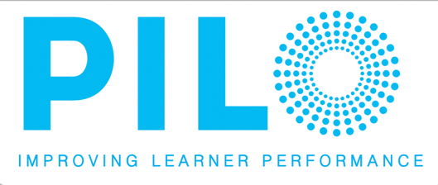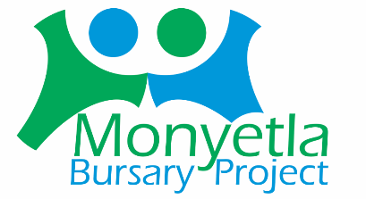

Enquiries:
Elijah Mhlanga: 083 580 8275 (Department Spokesperson)
Hope Mokgatlhe: 079 817 0427 (Minister’s Spokesperson)
Terence Khala: 081 758 1546 (Media Liaison)

ISSUED BY THE DEPARTMENT OF BASIC EDUCATION

