

**SCHOOLS COMPETITION APPLICATION FORM**

**Energy Efficiency & Awareness Competition**

Dear Sir/Madam,

**APPLICATION FOR PARTICIPATION IN THE ENERGY EFFICIENCY & AWARENESS COMPETITION**

We hereby wish to confirm the participation in the Msunduzi Municipality’s Energy Efficiency & Awareness Competition, as outlined in your Terms and Conditions.

Our school will be participating in the following category:

* **Primary School (Grade 7):** Submission of an A3 poster/painting conveying a message on Energy Efficiency, Energy Sustainability, and Renewable Energy.  
  ***(TICK BOX)***

***or***

* **Secondary School (Grade 11):** Submission of a device/model (not exceeding 60cm x 60cm) made from recycled materials and aligned with the themes of Energy Efficiency, Energy Sustainability, and Renewable Energy.

***(TICK BOX)***

**School Name: _____________________________________________________________**

**___________________________________________________________________________**

**Contact Number: __________________________________________________________**

**Email Address: ____________________________________________________________**

**Designation: ______________________________________________________________**

* The learners who will be involved in the design and preparation of our entry are:
* **Learner 1**

**Full Name of Learner: ______________________________________________________**

**___________________________________________________________________________**

**Grade:** ____________________________________________________________________

**Class Teacher/Coordinator: ________________________________________________**

* **Learner 2**

**Full Name of Learner: ______________________________________________________**

**___________________________________________________________________________**

**Grade:** ____________________________________________________________________

**Class Teacher/Coordinator: ________________________________________________**

**Terms and Conditions**

**1. Eligibility**

* The competition is open to all public schools within Pietermaritzburg, Primary and Secondary schools.
* Primary schools, Grade 7 students only and Secondary Schools Grade 11 students only.
* Schools must confirm their participation in writing via the application form.
* Two entries per school will be allowed (one student per entry)

**2. Entry Requirements**

* Primary (Grade 7) Schools are required to Design an A3 poster/painting and Secondary Schools (Grade 11) to build a device/model (max. 60cm x 60cm) out of recycled materials
* The submissions must convey a clear message regarding Energy Efficiency, Energy Sustainability and Renewable Energy concept.

**3. Judging Process**

* All poster/painting and device/model will be evaluated and marked by a panel of judges.
* Schools will be grouped into two categories:

1. Primary Schools (Grade 7)
2. High Schools (Grade 11)

* **Judging Criteria:**

1. Primary (Grade 7) Schools are required to Design an A3 poster/painting.

**Presentations will be evaluated on:**

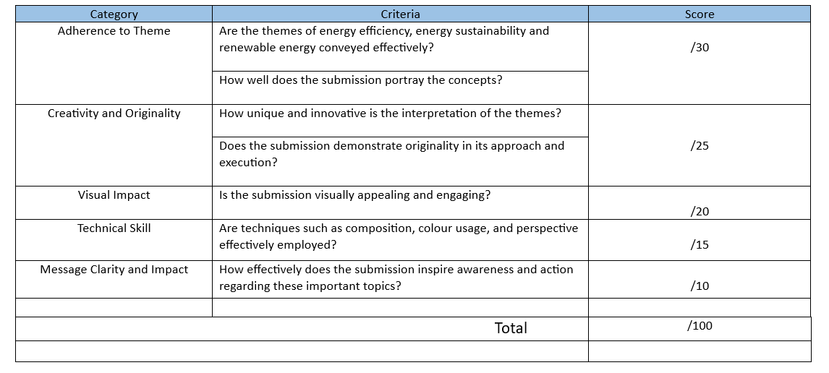

1. Secondary Schools (Grade 11) to build a device/model (max. 60cm x 60cm) out of recycled materials

**Models/Devices will be evaluated on**:

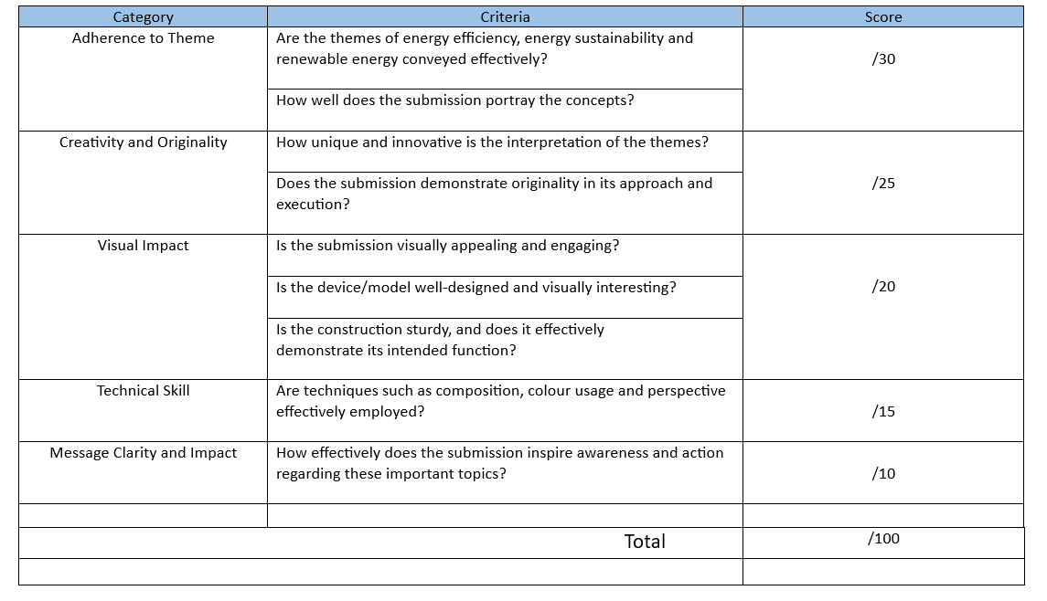

**5. Prizes**

* Prizes will be awarded separately for each catergory:
* **Primary School**

|  |  |  |
| --- | --- | --- |
|  | **Student** | **School** |
| **1st Prize** | Scientific Calculator | Desktop Computer |
| **2nd Prize** | Power Bank | N/A |
| **3rd Prize** | Rechargeable Solar Light | N/A |

* **Secondary School**

|  |  |  |
| --- | --- | --- |
|  | **Student** | **School** |
| **1st Prize** | Scientific Calculator | Desktop Computer |
| **2nd Prize** | Power Bank | N/A |
| **3rd Prize** | Rechargeable Solar Light | N/A |

**6. General Rules**

* A3 poster/painting and device/model must be original work created by students.
* By entering, schools consent to the use of submitted materials and participation details for promotional purposes related to the competition.

**For more information, contact:**

* Mr Rajesh Surji

Telephone (033) 392 5050

Cell phone : 081 741 4648

* Mr Lungisani Ntuli

Telephone (033) 392 5790

Cell phone: 082 724 3636

We look forward to our participation and celebrating student innovation on Energy Efficiency.

We understand and accept the terms and conditions of the competition, including the judging criteria and general rules. We also acknowledge that the submission will be the original work of our learners and that by participating, we consent to the use of materials and participation details for promotional purposes related to the competition.

We appreciate this initiative and the opportunity to engage our learners in promoting awareness and innovation in sustainable energy practices.

Please do not hesitate to contact us should you require any additional information. We look forward to a successful and enriching participation.

Yours faithfully

Full Name: ______________________________________________________________________

Signature: _______________________________________________________________________

Designation (Educator): ___________________________________________________________