

Msunduzi Municipality

MFMA s71

Msunduzi Municipality

November 2020 Report

Budget & Treasury Office

Table of Contents

PART 1 – IN YEAR REPORT 3

1.1 Executive Summary 3

1.2 In-year Budget Statement Tables 5

PART 2 – SUPPORTING DOCUMENTATION 17

2.1 Debtors Analysis 17

2.2 Creditors Analysis 20

2.3 Investment Portfolio Analysis 21

2.4 Allocation and Grant receipts and Expenditure 22

2.5 Parent Municipality Financial Performance 26

2.6 Municipal Entity Financial Performance 29

2.7 Capital Programme Performance 30

2.8 Municipal Manager’s Quality’s Certification 37

# PART 1 – IN YEAR REPORT

## Executive Summary

**Legislative Requirements**

In terms of Section 71 of the MFMA, the Accounting Officer of the Municipality must by no later than 10 working days after the end of each month submit to the mayor of the municipality and the relevant provincial treasury a statement in the prescribed format on the state of the municipality’s budget reflecting the following particulars for that month and for the financial year up to the end of that month.

* Actual revenue, per revenue source;
* Actual expenditure, per vote;
* Actual capital expenditure, per vote;
* The amount of any allocations received and actual expenditure on grant allocations excluding expenditure on the equitable share.
* when necessary, an explanation of—
  + - any material variances from the municipality’s projected revenue by

Source, and from the municipality’s expenditure projections per vote;

* + - any material variances from the service delivery and budget implementation plan; and
* Any remedial or corrective steps taken or to be taken to ensure that projected revenue and expenditure remain within the municipality’s approved budget.

**FINANCIAL PERFORMANCE**

**Revenue:** The Year to Date (YTD) actual revenue generated for the month of November amounted to R 2.385 billion while the projected (YTD) budget amounted to R 2.503 billion (excluding capital transfers and contribution). This means that the municipality generated a little less revenue at the end of November than projected. The municipality should continue to monitor closely the revenue collection.

The Year to Date (YTD) actual service charges contributed R 1.447 billion towards the total municipal revenue basket; which is 61% of the total revenue basket and Transfers and subsidies contributed R 293.616 million which is 12% of the total revenue basket.

Revenue from Rental of facilities and equipment, Interest earned - external investments; Interest earned - outstanding debtors; Fines, penalties and forfeits and Licence and Permits generated the following variances when comparing year to date actual and year to date budget respectively -89%; -52%; -12%; -131% and -45%. The revenue collection from these sources is a less then what was projected for the month of November 2020.

Overall, in the fifth month of the 2020 / 2021 financial year, the municipality generated total revenue of R 2.385 billion excluding capital transfers and contributions against the year to date budget of R 2.503 billion. However, the municipality must closely monitor the levels of revenue generated and expenditure incurred to mitigate the risk of expenditure exceeding revenue, which create cash flow problems in a long run.

**Operating Expenditure:** The total actual YTD operating expenditure for the month of November amounted to R 2.308 billion while the YTD budget Operating Expenditure amounted to R 2.316 billion.

The operational expenditure is largely defined by bulk purchases (electricity & water) and employee related costs both accounting 78% of the total operating expenditure incurred for the period ending 30 November 2020. In light of the operating expenditure analysis above, the municipality has introduced cost-cutting measures and invented cost effective ways of doing business. The municipality must continue with these measures to monitor expenditure.

**Overall**, the municipality recorded a surplus of R 263.785 million for the month of November.

**Capital Expenditure:** The YTD capital expenditure budget for the month of November amounted to R 259.163 million, the actual YTD actual Capital expenditure incurred amounted to R 180.490 million resulting in a variance of -30 % when comparing year to date actual and year to date budget.

Underspending in national grants funded projects and internally funded projects is a serious cause of concern because under-expenditure on capital projects directly results in a negative impact on service delivery. The municipality has put measures in place to ensure the acceleration of expenditure on capital projects thereby improving on delivery of services.

**Grants Receipts:** The total year to date operational and capital grant receipts for the month of November amounted to R 715.454 million that is inclusive of equitable share of R 545.085 million and Capital transfers of R 116.204 million.

**Consumer Debt:** The total YTD consumer debt at the end of November 2020 amounted to R 4.759 billion. The municipality’s debt is continually increasing which poses a serious threat to the municipality’s future sustainability. The municipality must introduce measures to ensure acceptable levels of debt collections and thereby mitigating the risk of cash flow problems in future

## 1.2 In-year Budget Statement Tables

**Parent Municipality (Msunduzi Municipality Only)**

**Monthly Budget Statements Summary**

Table C1 below provides a summary of the overall performance of the Municipality and is unpacked in the sections that follow.



Table C2 provides the statement of financial performance by standard classification.



Table C3 presents the same information as table C2 above, the difference being that it’s by Municipal vote.



**Statement of financial Performance**

This schedule provides information on the planned revenue and operational expenditures against the actual results for the period ending 30 November 2020.



**Capital Expenditure**

Table C5 below reports on the capital expenditure by department (municipal vote) for single year as well as multiyear capital appropriations. The bottom part of the schedule looks at the functional classification of the capital projects.



A detailed analysis of the capital expenditure programme is provided in section 2.7 “Capital Expenditure Programme”.

Table C6 displays the financial position of the municipality as at 30 November 2020.



**Consolidated Budget Tables (With Municipal Entity: Safe City)**













# PART 2 – SUPPORTING DOCUMENTATION

## Debtors Analysis

The table presented below summarises the Debtors Age Analysis as at 30 November 2020



**Chart 1: Debtors Age Analysis by Customer Group**

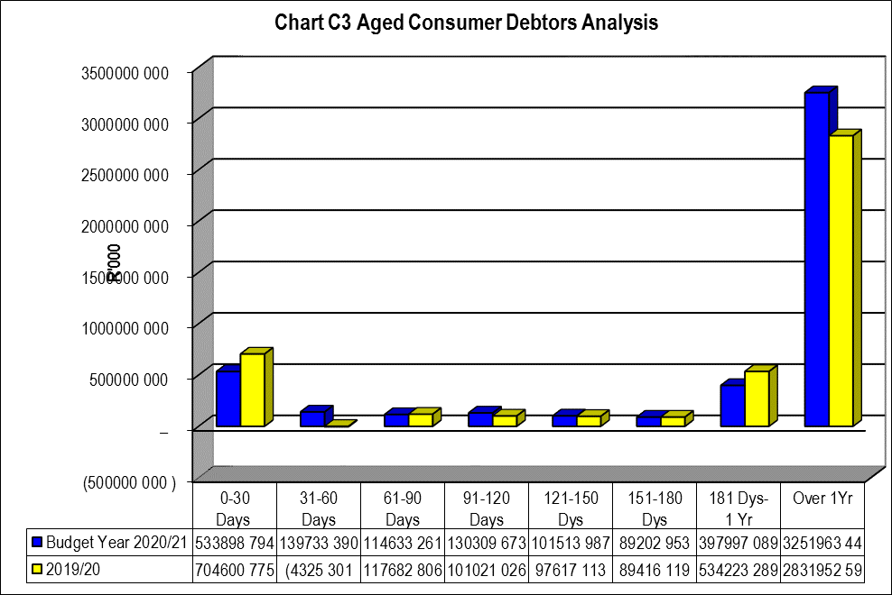

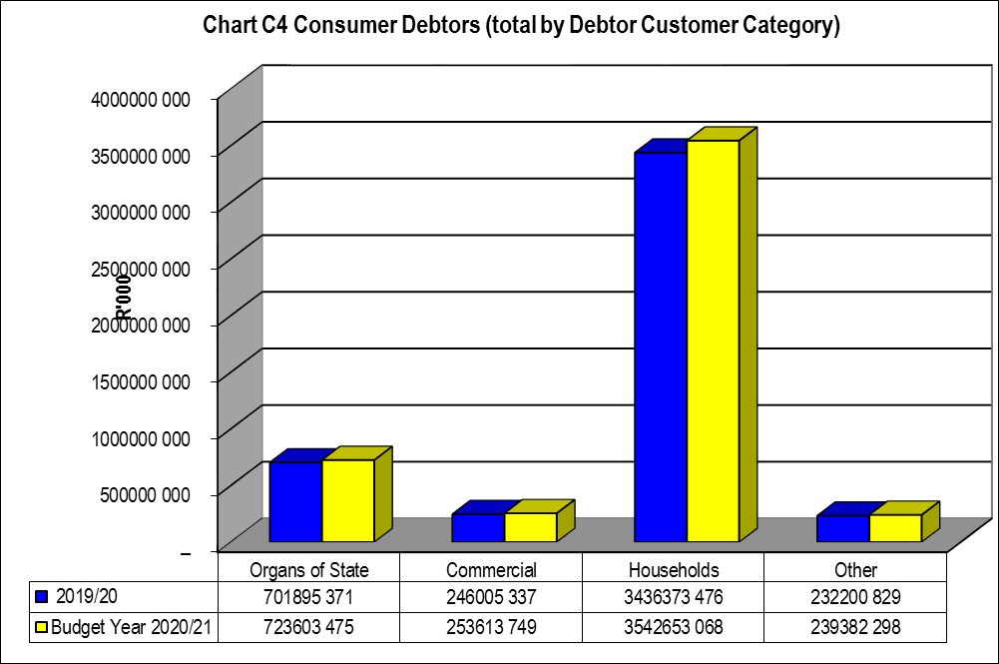

The information presented in the chart above reflects an increase in the outstanding debtor’s balances when compared to the prior month balance bringing the total outstanding debtors balance to R 4.759 billion.

Total debt owed to the municipality ranked from highest to lowest for current budget year reflects that households owe 75% of the total municipal debt as detailed below:

* Households 75%
* Commercial 5%
* Organs of State 15%
* Other 5%

## Creditors Analysis

Table SC 4 below presents the aged creditors as at 30 November 2020



The chart below presents the creditors per their source for the month ending 30 November 2020.

**Chart 3: Creditors Analysis**

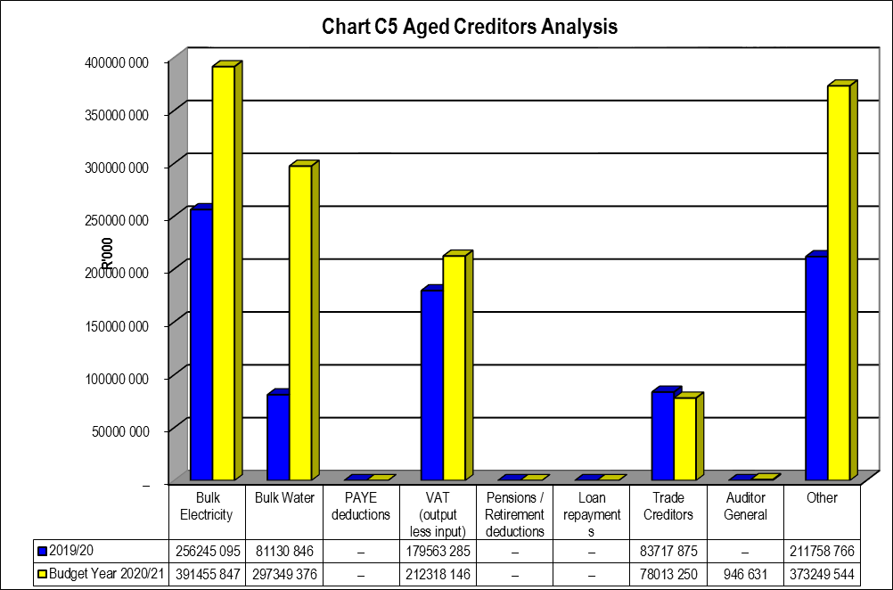

## Investment Portfolio Analysis

The following information presents the short-term investments balances broken down per investment type as at 30 November 2020.



The total consolidated investment balances as at 30 November 2020 amounted to R 142.625 million

## Allocation and Grant receipts and Expenditure

**Grant Receipts:** The total year to date operational and capital grant receipts for the month of November amounted to R 715.454 million that is inclusive of equitable share of R 545.085 million and Capital transfers of R 116.204 million.



**Grants Expenditure:** The YTD budget grant expenditure for the month of November 2020 amounted to R 537.655 million, and YTD actual expenditure amounted to R 196.828 million



**Councillor and Board Member and Employee Benefits**



**Councillor Allowances**

The expenditure on councillor allowances year to date budget for month of November 2020 amounted to R 22.354 million. The year to date actual councillor’s allowance amounted to R 21.626 million.

**Employee Benefits**

The total consolidated year to date actual salaries expenditure as at 30 November 2020 amounted to R 619.192 million, against the year to date budget of R 618.270 million.

The detailed staff benefits report is contained in the s66 report

## Parent Municipality Financial Performance

**REVENUE AND EXPENDITURE ANALYSIS**

The financial performance section analyses material variances between the actual targets as at year to date and the budget for the same period. This report analyses each major component under following headings;

* Revenue by Source and
* Operational Expenditure by Type

* + 1. **FINANCIAL PERFORMANCE**

**REVENUE ANALYSIS**

**Chart 4: Revenue Analysis**

The chart below presents the eighth month’s year to date actual revenue movements against the year to date budgets movements by source of revenue.

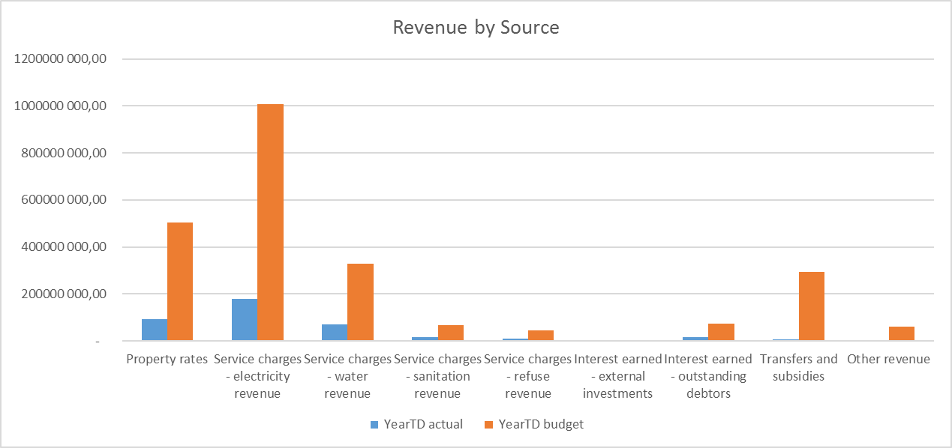

**Service Charges – Electricity Revenue:** This is a major revenue source of the Municipality; contributing 42% of the total operating revenue basket as at 30 November 2020. The year to date actual revenue earned from electricity service charges amounted to R 1.006 billion and the year to date budget amounted to R 1.077 billion.

**Property Rates:** Thisis the second largest revenue source of the Municipality; contributing 21% of the total operating revenue basket as at 30 November 2020. The year to date actual revenue earned from property rates slightly under performed by -5% when compared to the Year To Date (YTD) Budget.

**Service Charges - Water revenue:** The revenue earned from Water charges shared 14% of the YTD actual revenue, there is an over performance of 10% when comparing YTD actual to YTD Budget.

**Service Charges - sanitation revenue:** The revenue earned from Sanitation service charges shared 3% of the YTD actual revenue, and reflects an over performance of 4% when comparing the YTD actual revenue to the YTD budget.

**Service Charges - refuse revenue:** The revenue earned from refuse service charges shared 2% of the YTD actual revenue, reflects a variance of -8% when comparing the YTD actual revenue to the YTD budget.

**Transfers recognised – Operational** is made up of all operational grants funding mainly from the National & Provincial Government Departments, the largest of these being the equitable share.

**Interest earned – outstanding debtors** contributed 3% to the total operating revenue.

**OPERATIONAL EXPENDITURE ANALYSIS**

The chart below presents the fifth month’s year to date operational expenditure movements against the year to date budget movements by type

**Chart 5: Expenditure by Type**

|  |  |
| --- | --- |
|  |  |
|  |  |

**Employee Related Costs:** There is variance of -3% in respect of actual YTD expenditure on employee related costs against the YTD budget. This is due to post that are vacant and yet to be filled. A detailed line item and business unit analysis of the employee related cost is contained in the MFMA S66 report on staff benefits.

**Other Expenditure:** The YTD budget amounted to R 68.564 million while the year to date actual costs incurred amounted to R 66.742 million resulting in an under expenditure of R 1.822 million when comparing year to actual against year to date budget.

**Finance Charges:** The Finance charges have 8% variance when comparing the YTD budget and YTD actual.

**Contracted Services:** YTD Budget for contracted services amounted to R 204.385 million, whilst the actual year to date amounted to R 188.049 million, resulting in a variance of -8%

## Municipal Entity Financial Performance



## Capital Programme Performance

This next section looks at the performance of the capital expenditure programme. This performance is illustrated in the table that follow.



The Total Year to Date Actual Capital Expenditure as at the end of November 2020 amounted to R 180.490 million.

**Chart 5: Capital Expenditure by Vote**

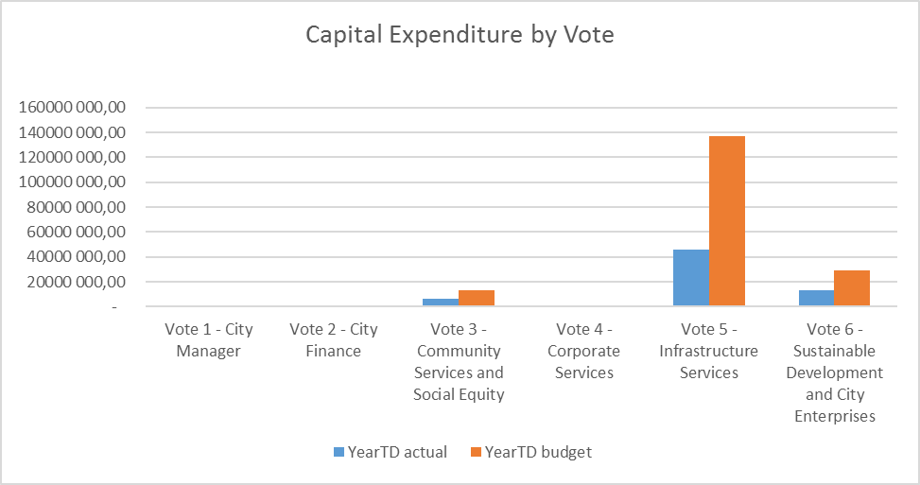







The chart below displays monthly trends of the Capital Expenditure and targets.

**Chart 6: Capital Expenditure Monthly Trend**

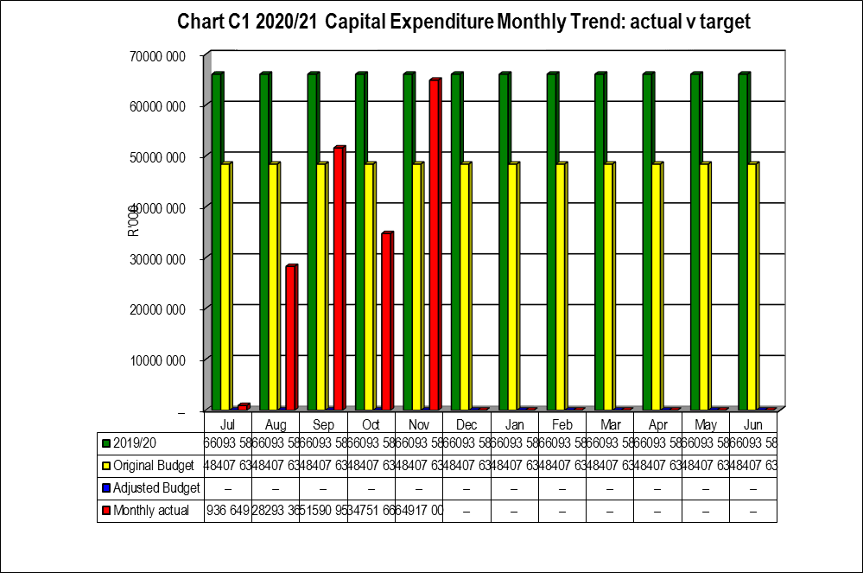

The Original Budget stipulates the budget for the year. The monthly actual figures stipulate a monthly trend.

The chart below, on the other hand, tracks the capital expenditure’s cumulative balances budget versus actual.

**Chart 7: Capital Expenditure: YTD Actual vs. YTD Target**

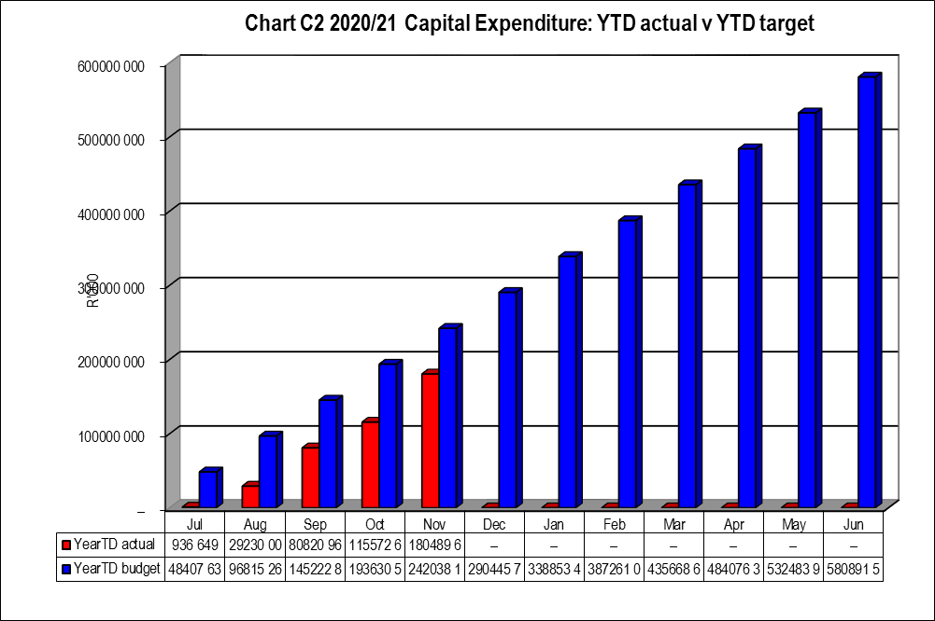

In Year report of Municipal Entities is attached to the Municipality’s in-year report

The municipal entity’s report for the month ending 30 November 2020 is attached.

## Municipal Manager’s Quality’s Certification

**Quality Certificate**

I, **Madoda Khathide**, the municipal manager of **MSUNDUZI LOCAL MUNICIPALITY**, hereby certify that –

* the monthly budget statement

for the month of **November 2020** has been prepared in accordance with the Municipal Finance Management Act and regulations made under that Act.

Print name: **Madoda Khathide**

Municipal manager of: **MSUNDUZI MUNICIPALITY**

Signature: ___________________________________________

Date: _______________________________________________