

Msunduzi Municipality

MFMA s71, s72 & s52 (d) Monthly, Mid-Year & Quarterly Reports

Budget & Treasury Office

Table of Contents

1. PART 1 – IN YEAR REPORT 3

**1.1** **Mayors Report** 3

**1.2** **Resolutions** 4

1.3 Executive Summary 4

1.4 In-year Budget Statement Tables 6

PART 2 – SUPPORTING DOCUMENTATION 18

2.1 Debtors Analysis 18

2.2 Creditors Analysis 21

2.3 Investment Portfolio Analysis 22

2.4 Allocation and Grant receipts and Expenditure 23

2.5 Parent Municipality Financial Performance 27

2.6 Municipal Entity Financial Performance 30

2.7 Capital Programme Performance 31

2.8 Municipal Manager’s Quality’s Certification 37

# PART 1 – IN YEAR REPORT

* 1. **Mayors Report**
  2. **Resolutions**

## 1.3 Executive Summary

**Legislative Requirements**

In terms of Section 72 of the MFMA, the Accounting Officer of the Municipality is required to submit a report in the prescribed format to the Mayor by the 25 January of each year, reviewing the financial performance of the municipality for the first six months of the year.

This mid-year report is a critical stage in the in year reporting cycle of the municipality as it allows the municipality to review any circumstances that may have changed since the preparation of the annual budget.

As part of the review, in terms of Section 72(3), the accounting officer needs to make recommendations as to whether the SDBIP and Annual budget, i.e. Both Operational & Capital, needs to be adjusted. Furthermore, Section 54(f) of the MFMA requires the Mayor to consider and submit a report to Council by 31 January.

**FINANCIAL PERFORMANCE**

**Revenue:** The total year to date (ytd) actual revenue generated for the month of December amounted to R 3.049 billion while the projected ytd budget amounted to R 3.003 billion. This means that the municipality generated slightly above what was projected at the end of the sixth month.

The variances on Property Rates revenue, Electricity revenue, Refuse removal revenue and Water revenue are below 10%, which is an acceptable level. However, revenue from Transfers and subsidies has a variance of 48%. This means that revenue generated from this source is higher than projected in the annual budget. However, the municipality will continue to monitor this area closely.

Revenue from External investments, Fines and Other revenue is less than initially projected in the annual budget. Therefore, the estimates should be adjusted downwards in the adjustments budget.

Overall, in the sixth month of the year, the municipality generated 3.049 billion revenue against the annual budget of R6.007 billion, which is 51% of the annual budget. The municipality must monitor closely the levels of revenue generated and expenditure incurred to mitigate the risk of expenditure exceeding revenue as that may create cash flow problems in a long run.

**Operating Expenditure:** The total year to date (ytd) actual operating expenditure for the period ending 31 December 2020 amounted to R 2.718 billion while the ytd budget amounted to R 2.779 billion. Operational expenditure is largely defined by the bulk (electricity & water) purchases and employee related costs both accounting for 74% of the annual budget expenditure.

Overall, the municipality recorded a surplus of R583.250 million for the sixth month of the financial year.

**Capital Expenditure:** The year to date (ytd) actual capital expenditure for the period ending 31 December 2020 amounted to R246.597 million while the ytd budget amounted to R 310.996 million resulting in underperformance of R64.399 million (-21%) of the capital budget. This is a serious cause of concern because under-expenditure on capital projects directly results in a negative impact on service delivery. The municipality should therefore put measures in place to ensure that the acceleration of expenditure on capital projects thereby improving on delivery of services.

**Grant Receipts:** The total operational and capital grant receipts for the sixth month amounted to R355.249 million while the expenditure amounted to R 60.548 million which only amounts to 17 percent performance against receipts.

**Cash & Cash equivalents:** As at the end of 31 December 2020 the cash and investments resulted in a positive balance amounting to R272.945 million.

**Consumer Debtors:** Consumer debtors at the end of the sixth month (31 December 2020) is at R 4.772 billion. The municipality’s debtors are continually increasing which poses a serious threat to the municipality’s future sustainability. A significant amount of debtors relates to household debtors’ category which amount to R3.5 billion, of which R3.1 billion has been outstanding for more than 90 days. Commercial debtors are the second largest category of debtors owed to the municipality amounting to R725 million, of which R447 millions of those debtors have been outstanding for more than 90 days. The lowest category of debtors owed to the municipality relates to Organ of the states which amounts to R222.7 million, it should be noted although this category is considered the lowest, if efforts are made by the organs of the state owing the municipality in ensuring this balance is reduced, this may make a significant difference in the municipality’s cash flow position. Achieving the collection overall in all categories will save the municipality from the significant Cash Flow risk exposure as it will always be liquid and able to pay its debts as they become due. The municipality will continuously introduce measures to ensure acceptable levels of debt collections and thereby mitigating the risk of cash flow problems in future.

**Creditors:** Creditors owed by the municipality as at the end of mid-year amount to R507 million.

## In-year Budget Statement Tables

**Parent Municipality (Msunduzi Municipality Only)**

**Monthly Budget Statements Summary**

Table C1 below provides a summary of the overall performance of the Municipality and is unpacked in the sections that follow.



Table C2 provides the statement of financial performance by standard classification.



Table C3 presents the same information as table C2 above, the difference being that it’s by Municipal vote.



**Statement of financial Performance**

This schedule provides information on the planned revenue and operational expenditures against the actual results for the period ending 31 December 2020.



**Capital Expenditure**

Table C5 below reports on the capital expenditure by department (municipal vote) for single year as well as multiyear capital appropriations. The bottom part of the schedule looks at the funding sources of the capital projects.



A detailed analysis of the capital expenditure programme is provided in section 2.7 “Capital Expenditure Programme”.

Table C6 displays the financial position of the municipality as at 31 December 2020.



**Consolidated Budget Tables (With Municipal Entity: Safe City**













# PART 2 – SUPPORTING DOCUMENTATION

## Debtors Analysis

The table presented below summarises the Debtors Age Analysis as at 31 December 2020.

**Table 2.1.1: Debtors Age Analysis by Income Source**



**Chart 1: Debtors Age Analysis by Customer Group**

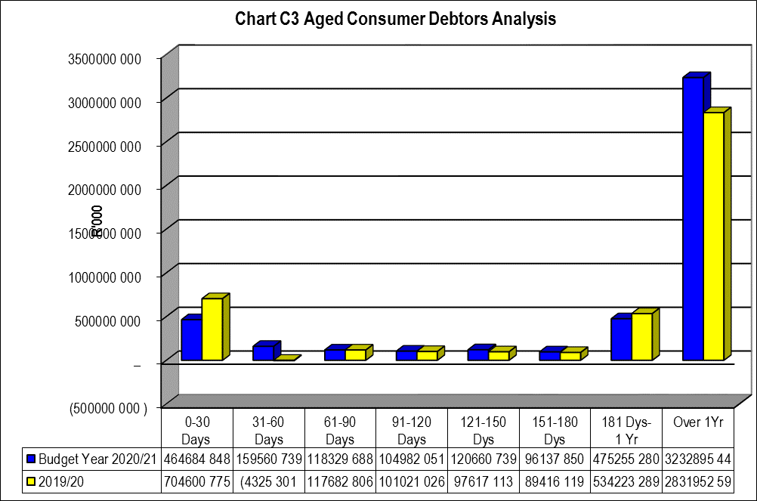

**Chart 2: Year on Year Debtors Age Analysis**

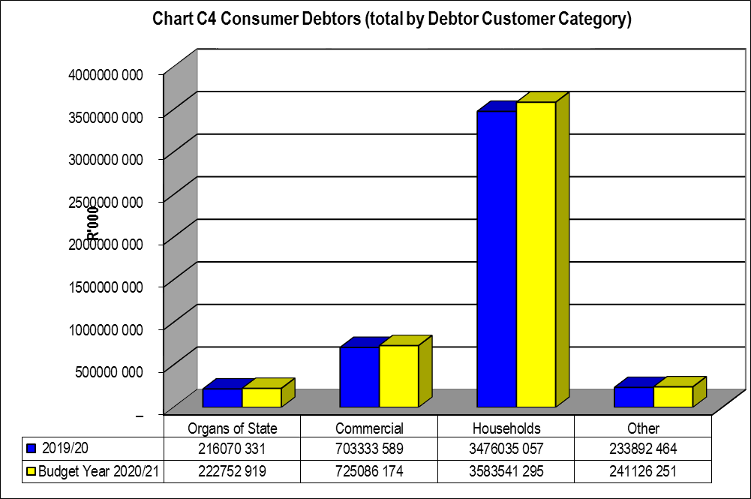

The information presented in the chart above reflects an increase in the outstanding debtor’s balances when compared to the prior month balance bringing the total outstanding debtors balance to R 4.772 billion.

Total debt owed to the municipality ranked from highest to lowest for current budget year reflects that households owe 74% of the total municipal debt as detailed below:

* Households 75%
* Commercial 15%
* Organs of State 5%
* Other 5%

## Creditors Analysis

Table SC 4 below presents the aged creditors as at 31 December 2020



The chart below presents a comparison of the age creditors between the current and prior year and for December month.

**Chart 3: Creditors Analysis**

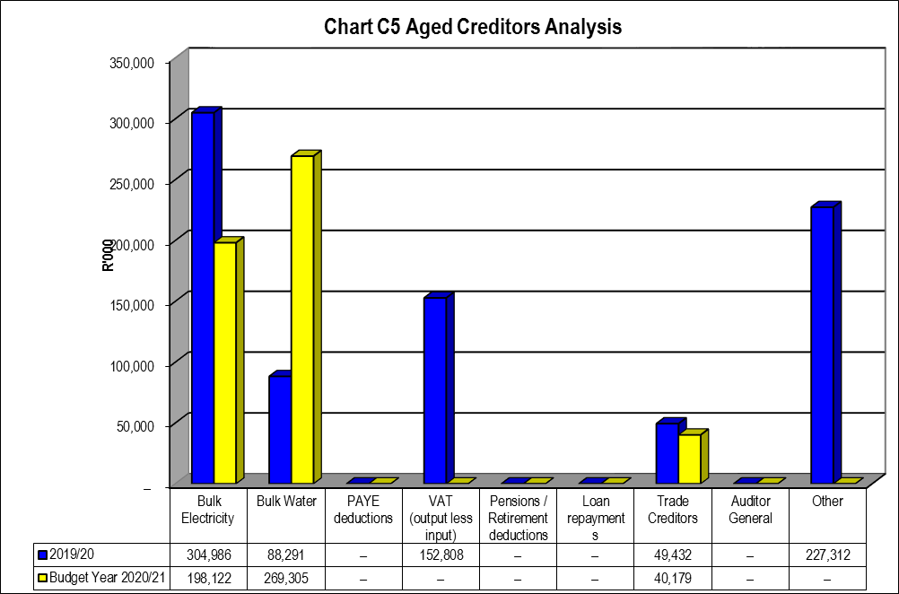

## Investment Portfolio Analysis

The following information presents the short term investments balances broken down per investment type as at 31 December 2020.



The total consolidated investment balances as at 31 December 2020 is R259.703 million

## Allocation and Grant receipts and Expenditure

**Grant Receipts:** The total operational and capital grant receipts for December 2020 amounted to R 747 Million, which includes the equitable share of R534. million.



**Grants Expenditure:** The amount spent in respect of conditional grants was R271 million during the first six months of the financial year.



**Councillor and Board Member and Employee Benefits**



**Councillor Allowances**

The expenditure on councillor allowances variance as at 31 December 2020 is -4%, which is acceptable. The year to date budget for Remuneration of Councillor’sis

R 26.825 million while the actual expenditure incurred was R 25.654 million resulting in an TYD little under expenditure performance.

**Employee Benefits**

The total consolidated salaries actual expenditure as at 31 December 2020 amounted to R731.960 million, against the year to date budget of R747.457 million, resulting in a slight under-expenditure of R15.497 million.

## Parent Municipality Financial Performance

**REVENUE ANALYSIS**

The financial performance section analyses material variances between the actual targets as at year to date and the budget for the same period. This report analyses each major component under following headings;

* Revenue by Source and
* Operational Expenditure by Type

* + 1. **FINANCIAL PERFORMANCE**

**Chart 4: Revenue Analysis**

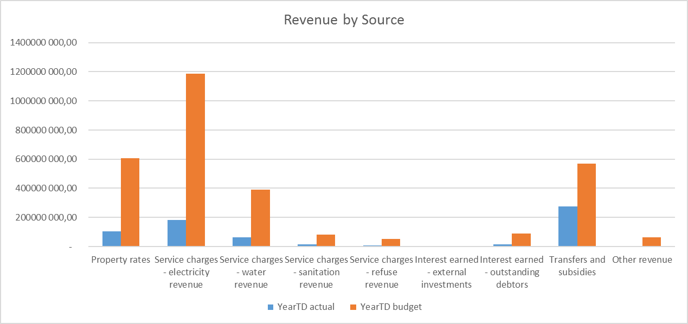

**Service Charges – Electricity Revenue:** This is a major revenue source of the Municipality contributing 39% to the actual Year operating revenue basket. The year to date revenue earned from electricity service charges had a -8% variance when compared to the Year to date Budget, which is an acceptable variance as it is less than 10%. The provision electricity is currently resulting in a gross profit.

**Property Rates** is the second largest contributor to the operating revenue basket making up 20% of the total operating revenue. There is a -4% variance when comparing year to date actual and year to date budget which an acceptable variance.

**Transfers recognised – Operational** is made up of all operational grants funding mainly from the National & Provincial Government Departments, the largest of these being the equitable share.

**Service Charges - Water revenue:** The revenue earned from Water charges shared 12% of the budgeted revenue basket and 13% of YTD actual revenue, there is a slight over performance against the budget causing a 8% variance when comparing YTD actual to YTD Budget. The provision of Water is currently resulting in a gross profit.

**Service Charges - sanitation revenue:** reflects an over performance of 6% variance when comparing the YTD actual revenue to the YTD budget. The provision of sanitation service is currently resulting in a gross profit.

**Service Charges - refuse revenue** reflects an under performance of -8% when comparing the YTD actual revenue to the YTD budget. . The provision of solid waste service is currently resulting in a gross profit.

**Interest earned – outstanding debtors** contributed 3% to the total operating revenue whilst **other revenue** contributed 2% to the total operating revenue received as at 31 December 2020.

**OPERATIONAL EXPENDITURE**

The chart below presents the Sixth Month YTD operational expenditure movements against the YTD budgets.

**Chart 5: Expenditure by category**

|  |  |
| --- | --- |
|  |  |
|  |  |

**Bulk Purchases:** YTD budget figure was R 1.304 billion while the actual costs incurred R1.399 million resulting in over-expenditure of R95 million.

**Employee Related Costs:** There is a under expenditure of R37.618 million in respect of actual YTD expenditure on employee related costs against the YTD budget. This is due to post that are vacant and yet to be filled. An improvement should be noted in the remaining six months of the financial year since some of these positions have been filled.A detailed line item and business unit analysis of the employee related cost is contained in the MFMA S66 report on staff benefits.

**Other Expenditure’s** YTD budget figure was R82.227 million while the actual costs incurred was R80.910 million resulting in under-expenditure of R1.367 million.

**Depreciation & Asset Impairment:** The depreciation & asset impairment YTD budget is R 240.746 million. The actual YTD being R212.356 million, which resulted in an under-expenditure of R28.39 million.

**Finance Charges:** YTD budgeted figure for finance charges for as 31 December 2020 amounted to R 18.25 million and the Actual YTD was R19.50 million which resulted in slight variance of R1.25 million.

**Contracted Services:** YTD Budget for contracted services amounted to R245.262 million, whilst the actual amounted to R233.983 million, which resulted in variance of R11.279 million.

## Municipal Entity Financial Performance



## Capital Programme Performance

This next section looks at the performance of the capital expenditure programme. This performance is illustrated in the table and charts that follow.



The Total Capital Expenditure as at the end of December amounted to R246.597 million.







The chart below displays a comparison between the previous year’s capital expenditure performances to that of the current year for the month under review.

**Chart 6: Capital Expenditure Monthly Trend**

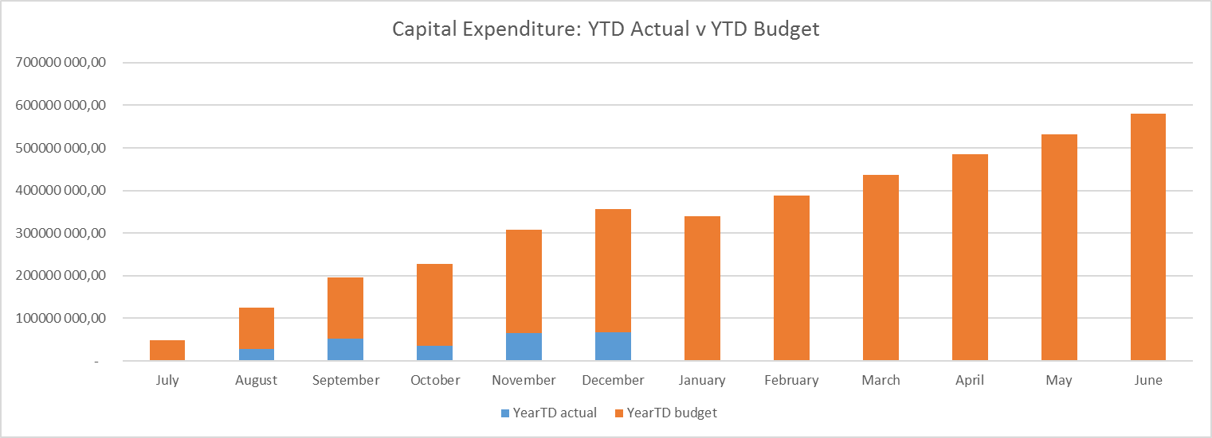

The chart below, on the other hand, tracks the capital expenditure’s cumulative balances budget versus actual.

**Chart 7: Capital Expenditure: YTD Actual vs. YTD Target**

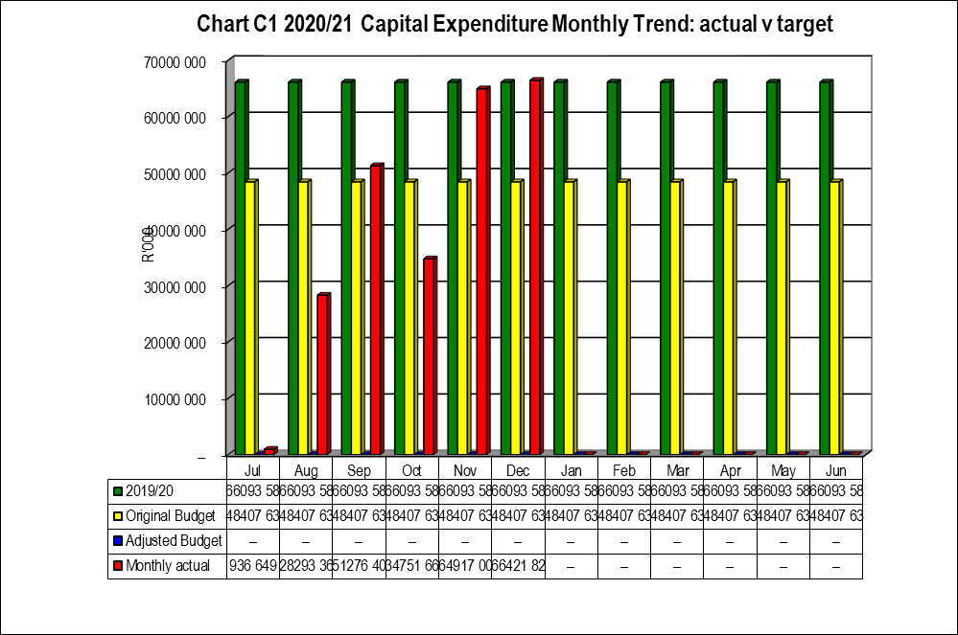

In Year report of Municipal Entities is attached to the Municipality’s in-year report

## Municipal Manager’s Quality’s Certification

**Quality Certificate**

I, **Madoda Khathide**, the municipal manager of **MSUNDUZI LOCAL MUNICIPALITY**, hereby certify that –

* the monthly budget statement

for the month of  **DECEMBER 2020/ SECTION 52d/ SECTION 71/ SECTION 72** has been prepared in accordance with the Municipal Finance Management Act and regulations made under that Act.

Print name: **M Khathide**

Municipal manager of: **MSUNDUZI MUNICIPALITY**

Signature: ___________________________________________

Date: _______________________________________________